Targeting: Lawyer Referral Partner
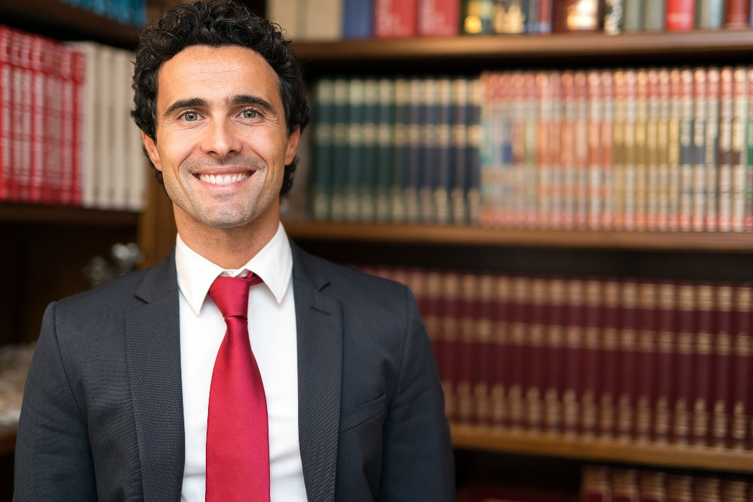
Are a lawyer looking to grow your business? Do you specialise in Family Law, Commercial Law or Property Law?
My name is (your name) and I’m an active Mortgage professional with a closed group of 500+ members who, from time to time, talk about subjects which relate to various aspects of law, and how it applies to them.
I am seeking to establish a reciprocal referral relationship with a lawyer who is equally as focussed on growing their business and their client base, and who would appreciate the value of being profiled within my closed group of followers
If this sounds like you, please complete the details the below and I’ll give you a call straight away. <name>

Targeting: Accountant Referral Partner
Are you an accountant or CPA looking to attract more clients? And, are you focussed on adding value to your clients life?
If so, I’d love to speak to you. My name is <name> and I am a mortgage professional with a closed Facebook group of 500+ interested and engaged members. Within my closed group members sometimes raise queries and open discussions relating to both individual and company tax, as well as corporate and family trust structures. Sometimes the members seek my expertise to refer them to the RIGHT tax professional.

At this point, I have no relationship in place with an Accounting professional who I can profile in my group.
So, I am seeking to establish a reciprocal referral relationship with an accountant who wants to grow their client base through referrals. I would like to be able to refer the members in the group to him/her in the event they require tax advice.

If this sounds like you, please click the learn more button, add your contact details and I’ll give you a call.
<name>

Targeting: Financial Adviser Referral Partner
Are you a financial adviser committed on seeing the world through your client’s eyes? Are you eager to grow your client numbers? Do you specialise in retirement planning, wealth creation and protection, or estate planning?
If so, I’d love to speak with you. I am a mortgage professional with a closed group of 500+ engaged interested members and clients all focussed on maximising the outcomes of their mortgage. Some of my clients from time to time seek direction and advice that a Financial adviser can offer.
I am seeking to establish a reciprocal referral relationship with a financial adviser who intrinsically understands the value they bring to their clients life and who is committed to nurturing their client relationships long term. If this sounds like you, please click the learn more button, add your contact details and I’ll give you a call.
<name>

